BÁO CÁO THỰC HÀNH LAB 1  
LẬP TRÌNH HƯỚNG ĐỐI TƯỢNG

# The Very First Java Programs

## *2.2.1* Write, compile the first Java application:

*Kết quả*

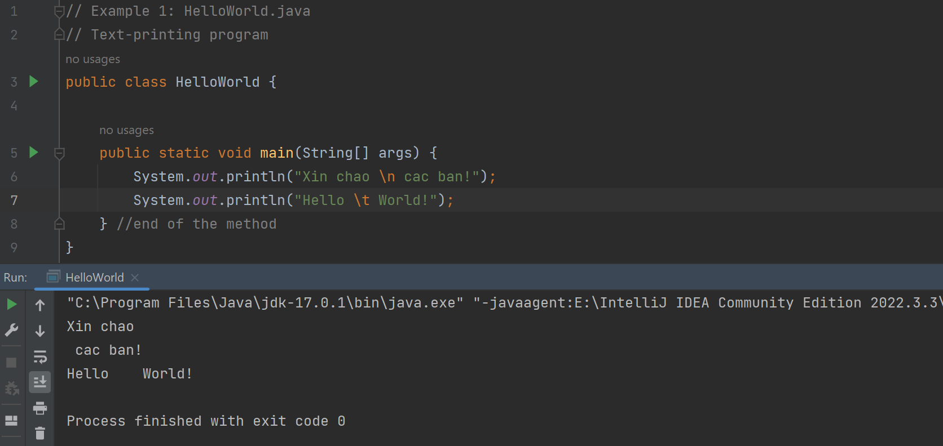

## 2.2.2 Write, compile the first dialog Java program

## 2.2.3 Write, compile the first input dialog Java application

## 2.2.4 Write, compile, and run the following example:

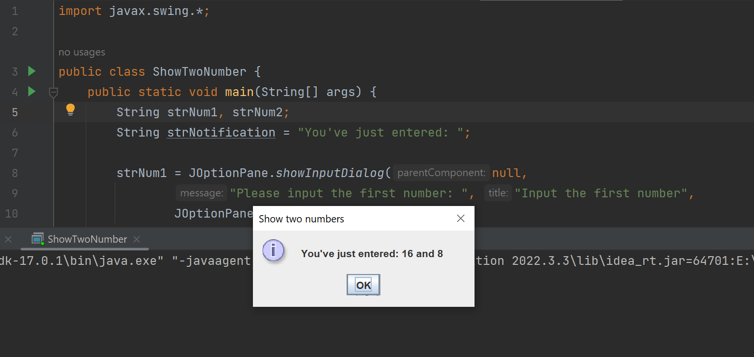

## 2.2.5 Write a program to calculate sum, difference, product, and quotient of 2 double numbers which are entered by users.

## 2.2.6 Write a program to solve:

**The first-degree equation**

**The system of first-degree equations (linear system) with two variables**

**The second-degree equation**

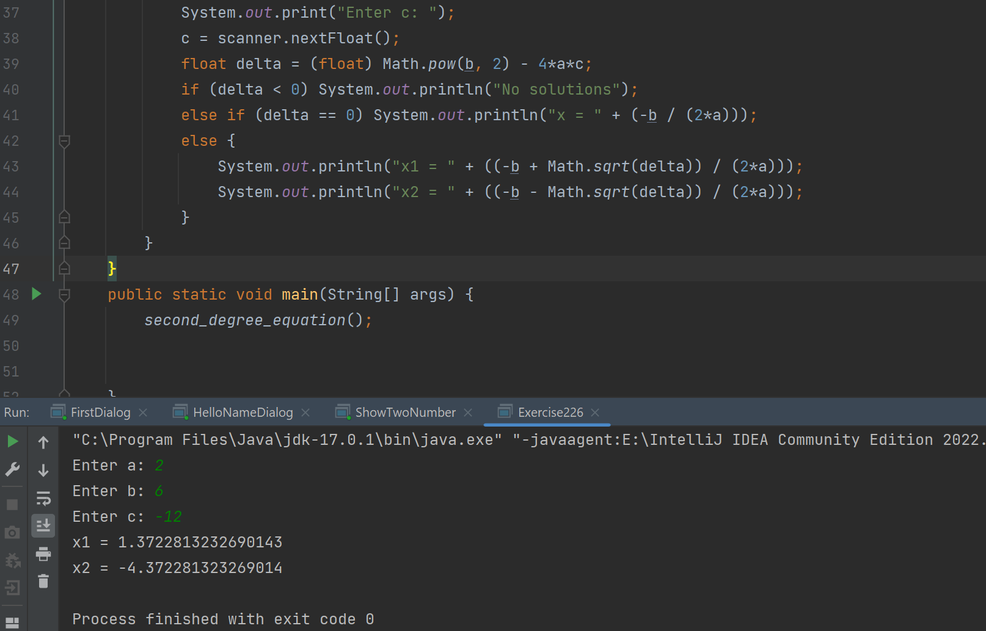

## 6.1 Write, compile and run the ChoosingOption program:

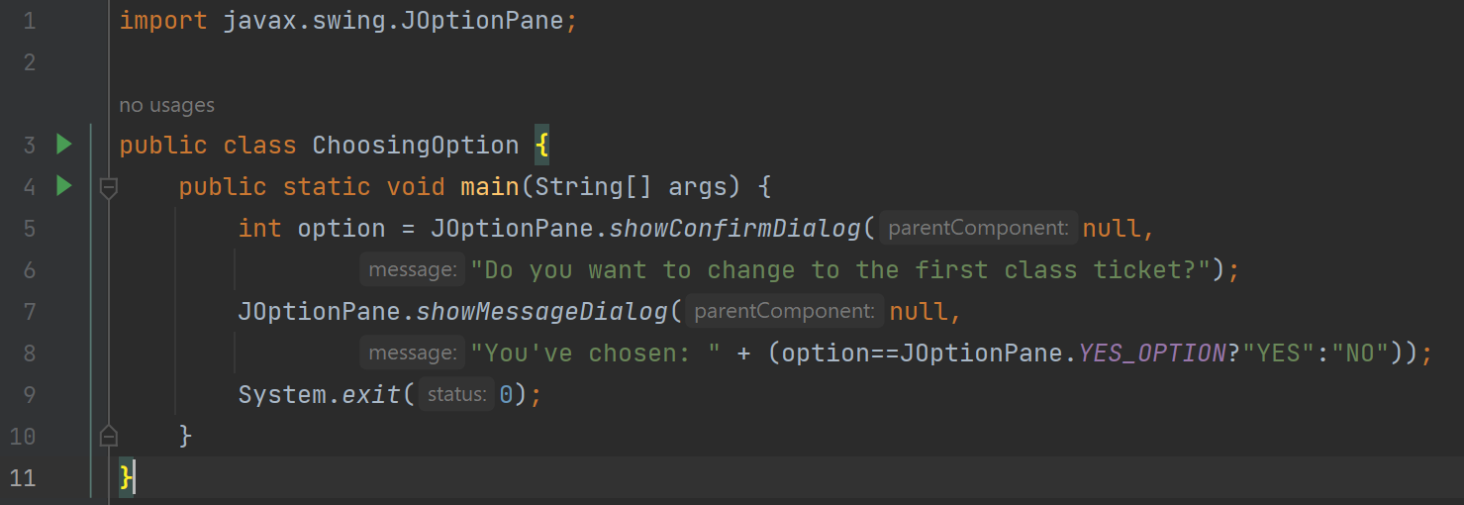

Questions:

* When users choose “Cancel”, the output is another dialog show “You ‘ve chosen: NO”

## 6.2 Write a program for input/output from keyboard.

## 6.3 Write a program to display a triangle with a height of n stars (*), n is entered by users.

## 6.4 Write a program to display the number of days of a month.

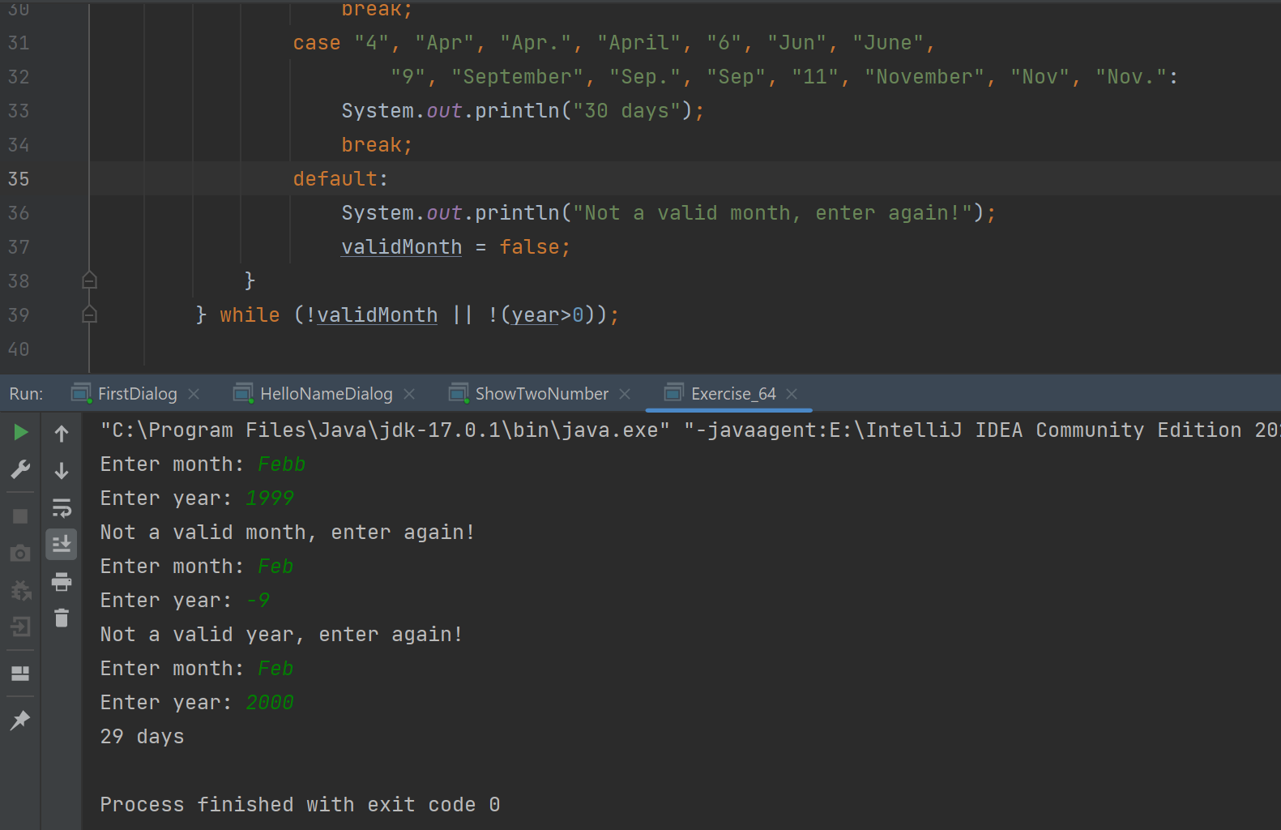





## 6.5 Write a Java program to sort a numeric array, and calculate the sum and average value of array elements.

## 6.6 Write a Java program to add two matrices of the same size.

